LETTER OF AUTHORIZATION ("LOA") 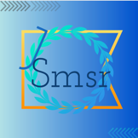

2022/12/5

To whom it may concern:

JSMSR AS134478 authorizes Xtom with AS3214 to advertise the following IP address blocks / originating ASNs:

2404:f4c0:f810::/44

2406:840:e180::/44

2a0e:b107:ea2::/48

2a12:dd47:80d0::/44

2a06:a005:d00::/44

2a06:a005:950::/44

2a0e:b107:1a90::/44

2a12:3fc2:e700::/40

2a0a:6040:d000::/40

2a06:a005:580::/44

2a12:3fc2:e700::/40

As a representative of the Company that is the owner of the aforementioned IP address blocks / originating ASNs, I hereby declare that I am authorized to sign this LOA on the Company’s behalf.

Should you have any questions please email me at admin@jsmsr.com , or call: +85254239525

Regards,

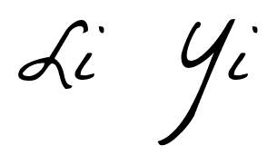

JSMSR | AS134478